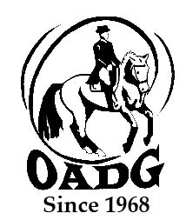

2026 OADG Para-Equestrian Award Submission Form
- (Must be submitted by the deadline on the OADG website)

This form is required if you are applying for the Para-Equestrian Award. Para-Equestrians must be declared by Equine Canada.

Criteria: See full criteria details on www.ottawadressage.ca/awards

Name of Rider: ______________________________________________

Name of Owner: _____________________________________________

Name of Horse: ______________________________________________

Notes:
- List eligible scores to three (3) decimal places.
- If your ride was judged by more than one judge, submit only the combined score.
- Only one (1) external score is allowed.
- If you are submitting an external score, include a website where the score can be verified (preferred method) or attach a copy of the test paper.

Results:
Show Location | Date | Class | Judge(s) | Score | Website

Sum of top three (3) eligible scores: _____________

Contact Name: ____________________________________________________________

Contact E-mail: _______________________________________________________________

Contact Phone Number: ________________________________________________________

Email to: awards@ottawadressage.ca (no signature required)

