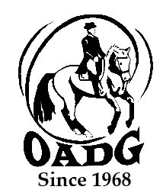

2026 OADG Team Challenge: Team Name Declaration (due April 1)
and Score Submission (due at year-end)

You must submit this form in April if you are entering the Team Challenge Award, and resubmit the updated form with the team scores at the end of the year. Final team results must be submitted by the deadline on OADG website.

A team consists of 3 or 4 horse-and-rider combinations. The top 9 scores (maximum 3 from any horse-and-rider combination) can be submitted for the awards calculations. See Awards Criteria for full details.

The deadline for declaring your team is April 1st. Team declarations will be accepted after this date but must be received before any member of the team competes (no scores will count until all members have been declared for the team).

Name of Team: ________________________________________________________________________

Show Circuit: (pick one): Virtual ESD Silver Gold / FEI (CDI/Platinum)

Names of Team Members (in April, provide names of all riders and horses, and JR/AA/O):
Rider | Horse | JR, AA, O | Show, date and class | Score
 |  |  | Total:

Contact Name: ____________________________________________________________

Contact E-mail: _______________________________________________________________

Contact Phone Number: ________________________________________________________

Email to: awards@ottawadressage.ca (no signature required)

