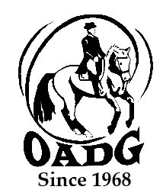

2026 OADG Young Horse Award Submission Form
- (Must be submitted by the deadline on the OADG website)

There is one combined Young Horse award for all eligible circuits (ESD, Silver, Gold and FEI).

Criteria: See full criteria details on www.ottawadressage.ca/awards

Circuit: (pick one): ESD Silver Gold FEI (CDI/Platinum)

Name of Horse: ______________________________

Age of Horse: ________ (must be 4, 5, or 6 years old as per the Equestrian Canada rulebook)

Name of Owner: _________________________________________________________________

Name(s) of Rider(s): ___________________________________________________________________

Notes:
- List eligible scores to three (3) decimal places.
- If your ride was judged by more than one judge, submit only the combined score.
- Only one (1) external score is allowed.
- If you are submitting an external score, include a website where the score can be verified (preferred method) or attach a copy of the test paper.

Results:
Show Location | Date | Class/Level | Judge(s) | Score | Website

Sum of top three (3) eligible scores: _____________

Contact Name: ____________________________________________________________

Contact E-mail: _______________________________________________________________

Contact Phone Number: ________________________________________________________

Email to: awards@ottawadressage.ca (no signature required)

